Date: April 23, 2008

To: Kathleen Hallihan, Director Arts and Science Curriculum Office
From: Valarie Williams Mockabee, Associate Dean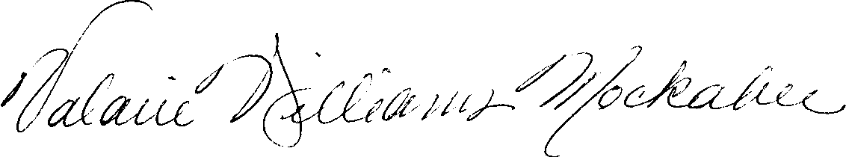

Re: African-American & African Studies 376

After discussing the course with faculty in the college and department chairs of Art and History of Art, we have determined that AAA 376 in its current form is not appropriate from our standpoint for VPA status. Please see Chair Shelton’s memo from March 31st paragraph two for reasons.

